## horizontal line

Comprehensive Fitness Planner & Health Platform

(FFSD PROJECT REPORT)

# Abstract Of the Project

The **Comprehensive Fitness & Wellness Platform** is a full-stack web application designed to provide personalized fitness solutions. It offers **customized workout plans, dietary guidance,** and **wellness recommendations** tailored to individual needs. With a focus on user engagement and professional guidance, the platform ensures a holistic approach to fitness.

# Features

## Core Features

### **Workout Plans**

* + Clients input their fitness level and goals (e.g., weight loss, muscle gain) to receive a structured plan.
  + Free workout plans are available. Paid plans include a guided nutritional diet from certified trainers.

### **Live workout classes**

* + Enable users to join live workout sessions led by trainers, with interactive features like live chat, progress tracking for an engaging fitness experience.

### **Workout Scheduler & Reminder System**

* + Schedule workouts and track progress using a calendar.
  + Set reminders via email or SMS.

### **Diet & Nutrition Planner**

* + Daily meal plans with calorie breakdowns.
  + Option to purchase standalone diet plans from certified nutritionists.

### **Trainer Video Library**

* + Trainers can upload videos related to physical and mental wellness.

### **Lab Test Recommendations**

* + Suggestions based on fitness goals, age, and health conditions.
  + Automated reminders for regular health checkups.

### **Blogs by trainers, nutritionists, and fitness professionals**

* + Blogs focusing on fitness and mental wellness.

## Auxiliary Features [Upcoming Semesters]

### **Booking Lab Tests**

* + Browse and book fitness-related lab tests.
  + Integration with nearby lab centers.

### **E-Commerce Store**

* + Sell fitness supplements, gym gear, and apparel.

# Users

## Admin

* + Manage user accounts
  + Verify trainers.
  + Approve fitness programs and diet plans.
  + Monitor site analytics and engagement.

## Fitness Enthusiast (Client)

* + Access personalized workout plans.
  + Follow diet and meal plans.
  + Read motivational blogs.
  + Receive lab test recommendations.

## Trainer

* + Upload workout videos and exercise guides.
  + Offer one-on-one fitness coaching (paid subscription).
  + Track client progress and provide recommendations.
  + Sell customized diet and training plans.

## Testing Lab (Upcoming Semesters)

* + Verify and manage lab test bookings made by clients.

# Forms and Pages

## Forms

* **User Registration**: Name, email, password, fitness level, goals.
* **Trainer Application**: Name, qualifications, certifications, document upload.
* **Workout Plan Submission**: Name, description, duration, difficulty level, category.
* **Feedback**: User feedback on workouts or platform experience.

## Pages

* **Home Page:** Visual introduction to the platform.
* **User Dashboard:** Displays personalized workout plans and goals.
* **Trainer Dashboard:** Allows trainers to upload and manage content.
* **Admin Dashboard:** Provides tools to authenticate and manage users and content.
* **Workout Plan Page:** Browse and select plans based on fitness level and style.
* **Blog Page:** Blogs on fitness and wellness.
* **Trainer Selection Page:** Clients choose trainers based on certifications (paid feature).
* **Nutrition Guide Page:** Detailed diet plans, protein calculators, and water trackers (paid feature).
* **Lab Test Recommendation Page:** Displays tailored lab test suggestions.
* **Feedback and Contact Page:** Collects user feedback and queries.
* **Registration and Login Page:** For new trainees and trainers.

# Workflow

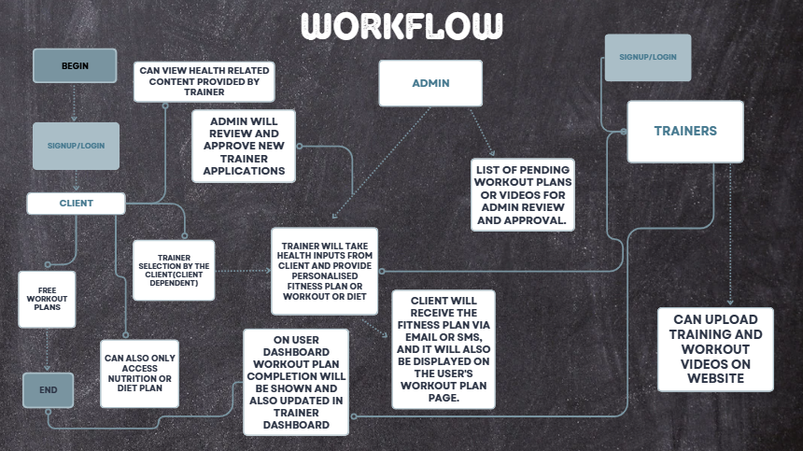

# Project Timeline

## Group Formation :

During the Zeroth Review, slides outlining a broader plan for our project and detailing the website's outlook will be presented. Suggestions will be gathered based on the presentation.

## Mid Review :

By this stage, the frontend of the website (HTML + CSS) will be completed. Specific forms, such as the User Registration Form, Trainer Application Form, Workout Plan Submission Form, and Feedback Form, will include proper JavaScript validation. Additionally, some backend functionality using an in-memory database will be implemented.

## End Review:

By the End Review, the project will be equipped with full backend functionality using RDBMS/NoSQL databases like MongoDB or PostgreSQL.

# Individual Contributions

## Dhruv Patel (S20230010180)

* **Frontend Development**: Create static pages using HTML, CSS, Bootstrap, and EJS templates.
* **Form Validation**: Add JavaScript-based validation for all forms.

## Krishna Suryawanshi (S20230010126)

* **Backend Setup**: Configure Node.js + Express server, middleware, and session handling.
* **In-Memory Database**: Implement temporary data storage and integrate with backend routes.

## V Nanda Kishore Reddy (S20230010248)

* **Database Integration**: Set up and integrate RDBMS/NoSQL for final deployment.
* **Backend Logic**: Implement user registration, login, and CRUD operations using MVC.

## S Bhargav Reddy (S20230010217)

* **Testing & Debugging**: Test and fix frontend/backend bugs.
* **Deployment**: Deploy the web app on a cloud platform and ensure functionality.

## V Siddhu (S20230010247)

* **UI/UX Design**: Create wireframes and enhance user experience.
* **Documentation**: Prepare project reports, user manuals, and setup guides.